**1.INDRODUCTION**

**OverView:**

* Now a days a lot of SMS floods the inbox those, SMS includes spam and helpful message. In today’s life we don't have enough time to recognize these SMS whether it is spam or not, and also Spam SMS can create a variety of business problems, including annoying customers, damaging brand reputation, legal compliance, wasted resources, and ineffective marketing.
* So in our Project, a model is developed in machine learning technique using kaggle.com Data sets.
* In our project SMS spam filtering is done by moving the spam SMS into separate folder and displaying only the essential SMS. The spam SMS can be filtered with highest efficiency. In this scenario , We also check if a message contains spam features such as spam keywords, some special characters or URLs and using machine learning algorithms like ,Random forest model, Decision tree, ANN and finally evaluates the performance metrics. Finally we deploy the model using web frame work.

**Purpose :**

* Optimizing spam filtering, using our Project or This model enables the people to avoid viewing the unwanted SMS messages, malicious links , frauds and the filtered messages will be a vital one. By filtering the Spam SMS, Essential SMS and Detail alone are viewed which we promote the service provider business aspect using android application.

**2) PROBLEM DEFINITION AND DESING THINKING**

**Empathy Map:**

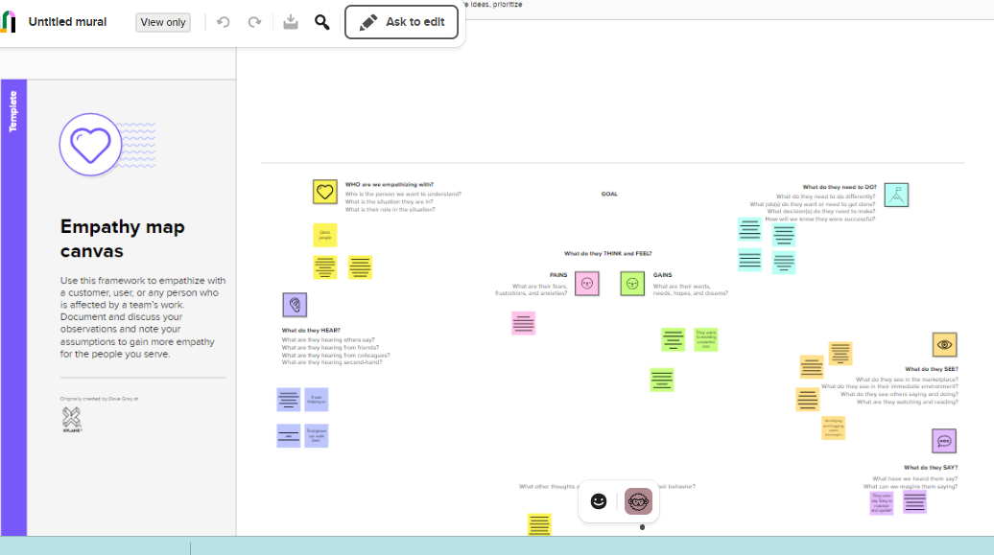

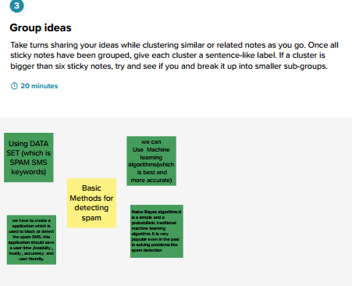

**Ideation and Brainstorming Map:**

Use this link for better view on MURAL.CO (<https://app.mural.co/t/spamdetection8160/m/spamdetection8160/1679194309486/11625e177f577b17830ff4f9f7e4f21f2c50fb2e?sender=u9c31cf3b5b25936298193924>)

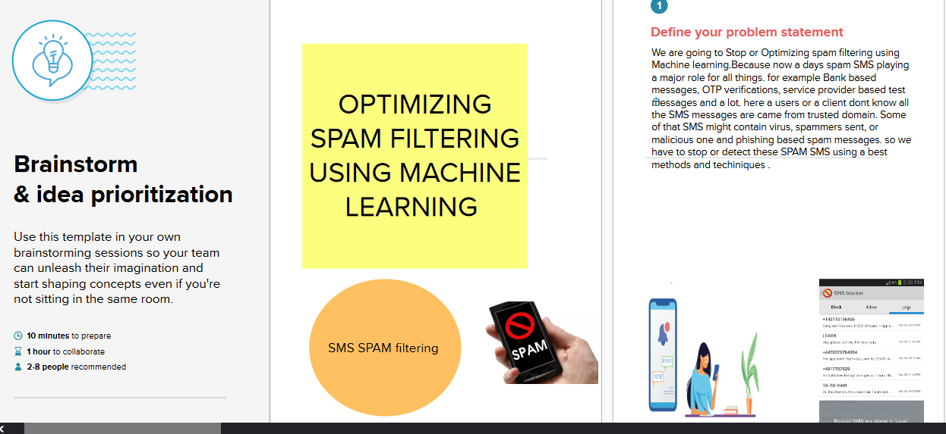

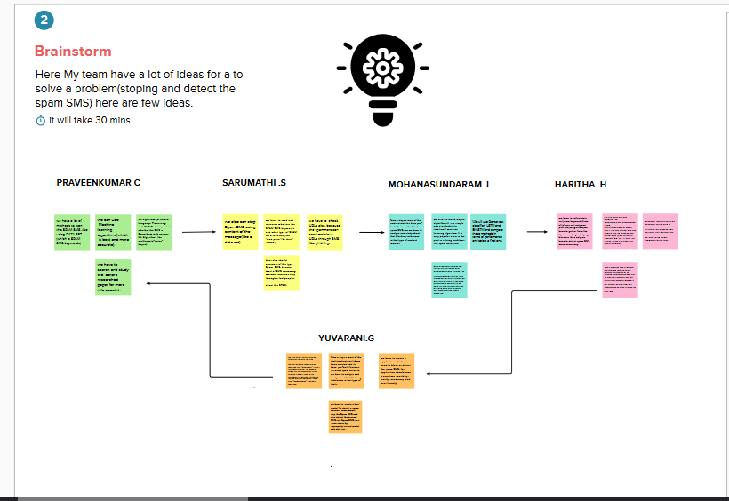

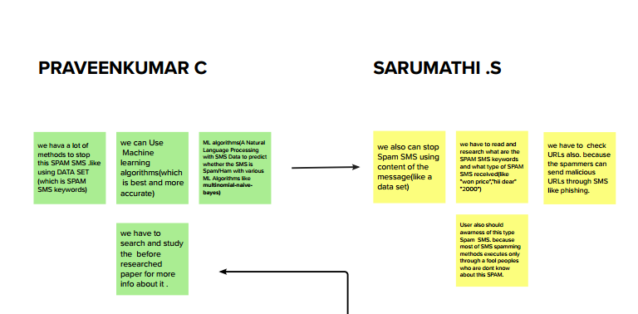

* 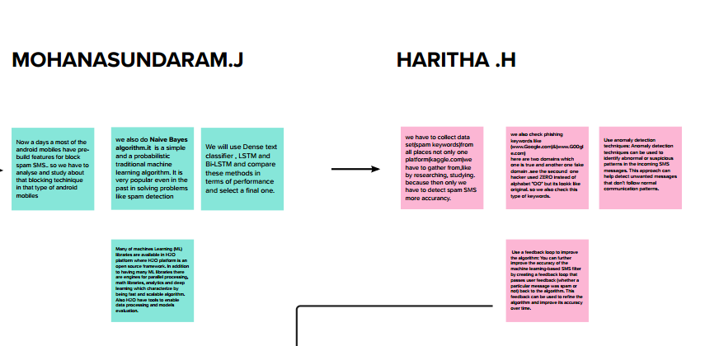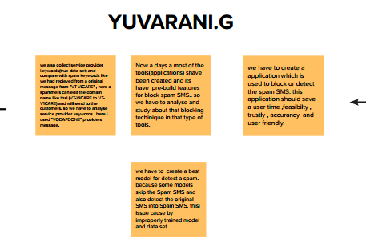



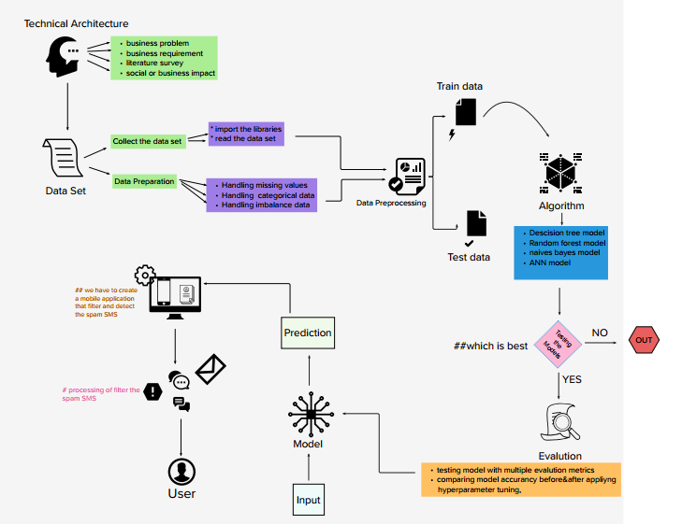

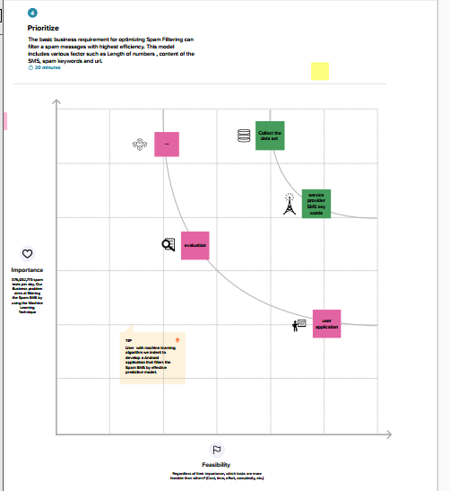

**3) RESULT:**

Output1 : Importing the libraries

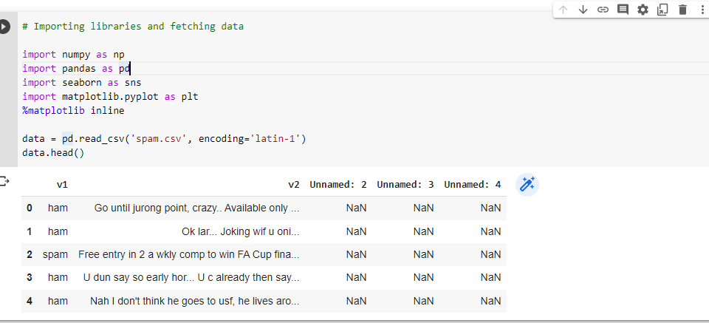

Output2 : Data analysis

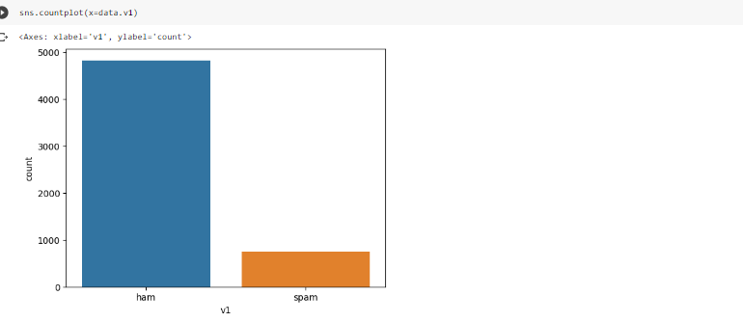

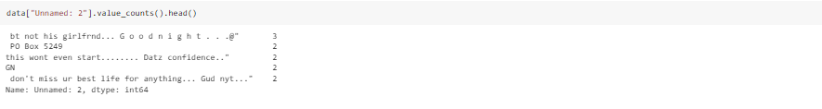

Output3:Create_model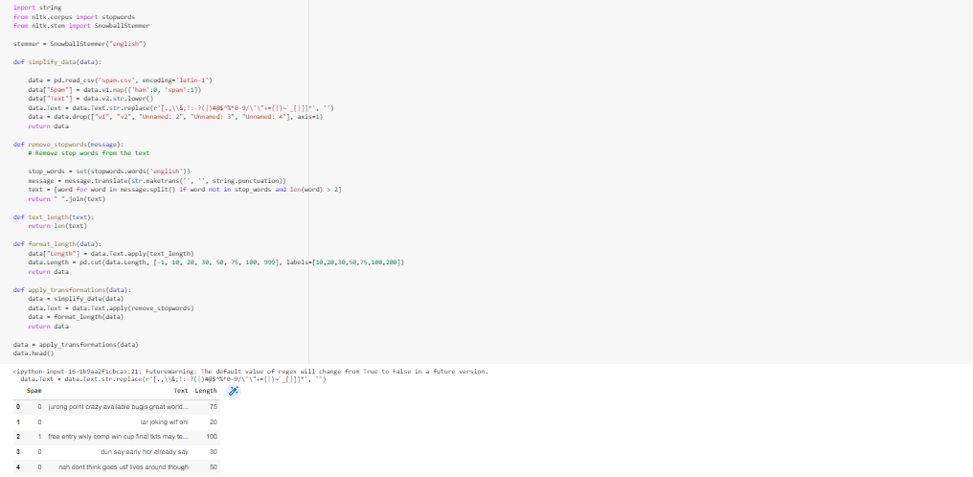

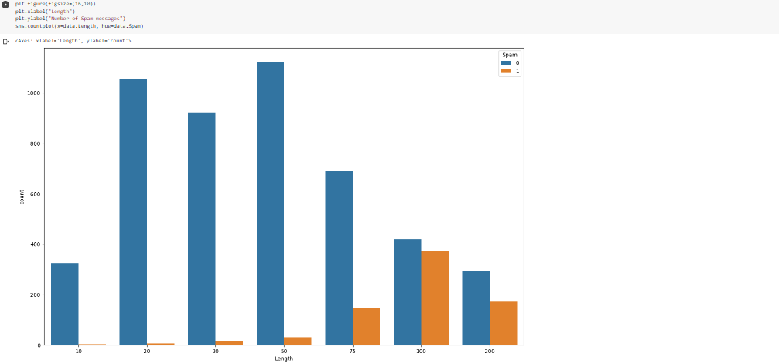

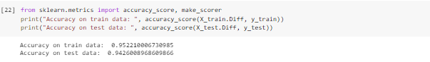

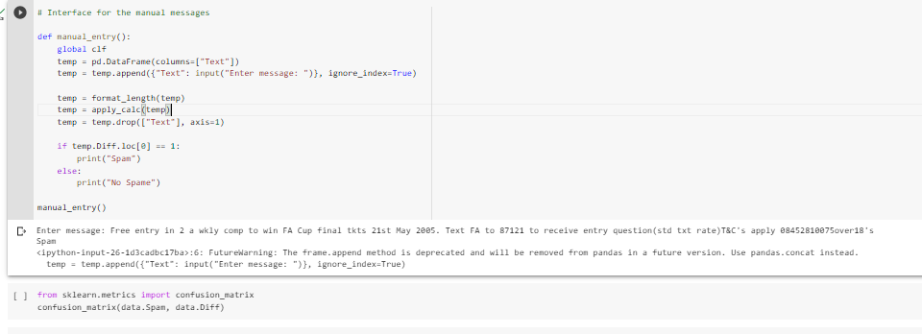

Output 4: Front end for the model

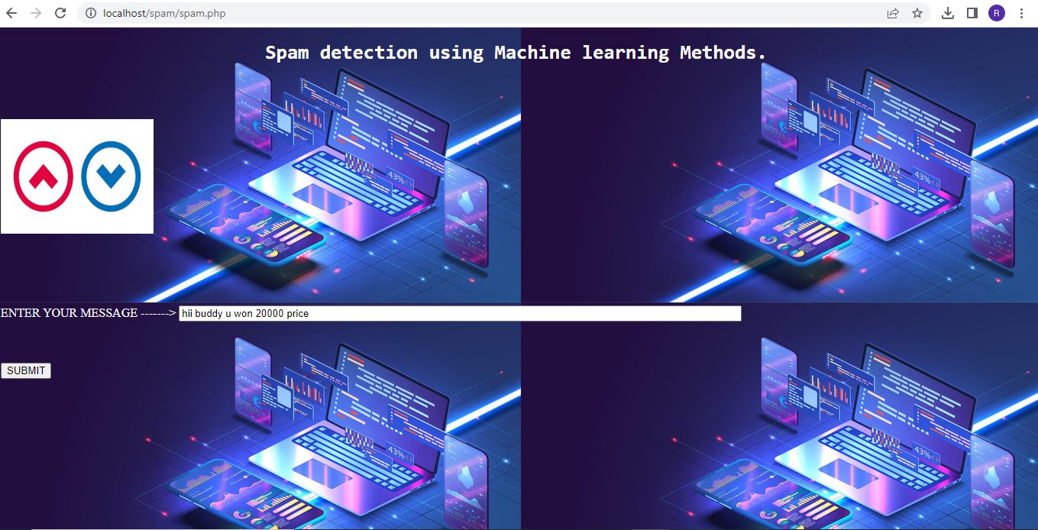

Output 5: final output

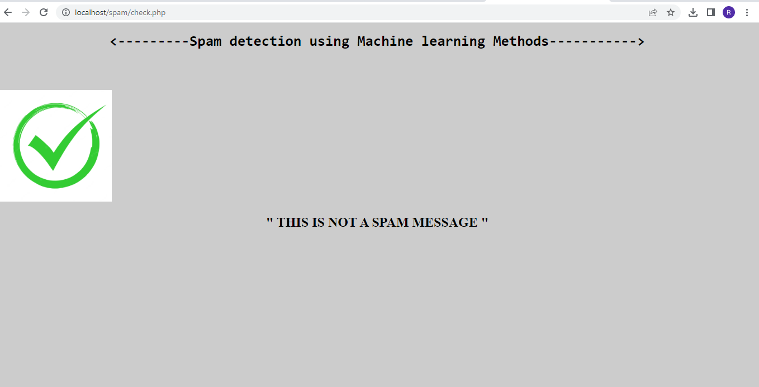

**4) ADVANTAGES AND DISADVANTAGE**

**Advantage :**

* The ideal anti-spam software(in our project) is the one that ensures you your privacy and blocks 99% percent of the SMS you do not want to receive.
* It can be customized to your needs, and only the approved SMS come into your inbox.
* This protects the user from any potential cyber threat and facilitates smooth communications and workflow

**Disadvantage :**

* But it is never going to be possible. Spammers are always inventing new techniques to trick the filters, and the developers of anti-spam software try not to overlook it.
* Thousands of spam SMS may reach Inboxes before a spammer's SMS s address, IP or domain is blacklisted. Spam filtering is machine-based so there is a room for mistakes called “false positives.
* Spam SMS can be the source of a great amount of malware like viruses, Trojans, worms, and others which are specifically designed to disrupt or damage computer systems.

**5) APPLICATIONS**

Recent updates about Spam SMS is Spammers tries to intrude in mobile Computing device. And SMS support for mobile devices had become vulnerable, as attacker tries to intrude to the system by sending unwanted link, with which on clicking those link the attacker can again remote access over the mobile computing device.

So , In our project( this application model )will be used or model enable the people to avoid viewing the unwanted SMS messages and all the filtered messages stands important . so we can use this model as a application in client androids and devices.

We can also use this model at Business side( eg : service provider ) , A lot of spam SMS came to our inbox which is look like similarly came from Service providers but that’s not originally came from service providers. (for example: VT-ViCARE , VT- V1CARE ) .By filtering the Spam SMS, Essential SMS and Detail alone are viewed which we promote the service provider business aspect using android application.

**6) CONCLUSION :**

In this end-to-end project we have learned how to approach a problem statement, and gather useful conclusions from the data using Data preprocessing, Data Visualisation which will help you build a good Machine Learning Model. In order to solve this classification problem we used the Naive Bayes Algorithm and in particular, the Multinomial Naive Bayes algorithm as it was having the highest precision score (i.e least False Positives)

**7) FUTURE SCOPE**

In the future, we plan to deal with more challenging problems such as the analysis and management of report in spam SMS filters storing. Solution for this problem is another focus of work in the

The future of SMS spam filtering using machine learning could involve incorporating more advanced techniques such as deep learning and natural language processing to further improve the accuracy of spam detection. Additionally, personalized spam filtering could be developed based on individual user preferences and message history. Overall, the application of machine learning to SMS spam filtering has the potential to greatly improve the user experience and reduce the annoyance and security risks associated with spam messages.

**8) APENDIX**

import numpy as np

import pandas as pd

import seaborn as sns

import matplotlib.pyplot as plt

%matplotlib inline

data = pd.read_csv('spam.csv', encoding='latin-1')

data.head()

sns.countplot(x=data.v1)

data.info()

data["Unnamed: 2"].value_counts().head()

import nltk

nltk.download('stopwords')

import string

from nltk.corpus import stopwords

from nltk.stem import SnowballStemmer

stemmer = SnowballStemmer("english")

def simplify_data(data):

data = pd.read_csv('spam.csv', encoding='latin-1')

data["Spam"] = data.v1.map({'ham':0, 'spam':1})

data["Text"] = data.v2.str.lower()

data.Text = data.Text.str.replace(r'[.,\\&;!:-?(|)#@$^%*0-9/\'\"+={|}~`_[|]]*', '')

data = data.drop(["v1", "v2", "Unnamed: 2", "Unnamed: 3", "Unnamed: 4"], axis=1)

return data

def remove_stopwords(message):

# Remove stop words from the text

stop_words = set(stopwords.words('english'))

message = message.translate(str.maketrans('', '', string.punctuation))

text = [word for word in message.split() if word not in stop_words and len(word) > 2]

return " ".join(text)

def text_length(text):

return len(text)

def format_length(data):

data["Length"] = data.Text.apply(text_length)

data.Length = pd.cut(data.Length, [-1, 10, 20, 30, 50, 75, 100, 999], labels=[10,20,30,50,75,100,200])

return data

def apply_transformations(data):

data = simplify_data(data)

data.Text = data.Text.apply(remove_stopwords)

data = format_length(data)

return data

data = apply_transformations(data)

data.head()

#data visual

plt.figure(figsize=(16,10))

plt.xlabel("Length")

plt.ylabel("Number of Spam messages")

sns.countplot(x=data.Length, hue=data.Spam)

spam_words = []

ham_words = []

def getSpam(text):

global spam_words, spam_messages

messages = text.split()

words = [x for x in messages]

spam_words += words

def getHam(text):

global ham_words, ham_messages

messages = text.split()

words = [x for x in messages]

ham_words += words

# Separate spam and ham messages

spam_messages = data[data["Spam"] == 1]["Text"]

ham_messages = data[data["Spam"] == 0]["Text"]

# Store common words in Spam/Ham

spam_messages.apply(getSpam)

ham_messages.apply(getHam)

def countSpam(text):

count = 0

for x in text.split():

if x in spam_words:

count += spam_words.count(x)

return count

def countHam(text):

count = 0

for x in text.split():

if x in ham_words:

count += ham_words.count(x)

return count

def getCounts(data):

SpamCount = data.Text.apply(countSpam)

HamCount = data.Text.apply(countHam)

data["Diff"] = SpamCount - HamCount

return data

def categorize(diff):

if diff <= 0:

return 0

else:

return 1

def apply_calc(data):

data = getCounts(data)

data.Diff = data.Diff.apply(categorize)

return data

data = apply_calc(data)

data.head()

spam_words.count("free")

ham_words.count("free")

from sklearn.model_selection import train_test_split, GridSearchCV

X = data.drop(["Spam"], axis=1)

X_train, X_test, y_train, y_test = train_test_split(X, data.Spam, test_size=0.2, random_state=23)

from sklearn.metrics import accuracy_score, make_scorer

print("Accuracy on train data: ", accuracy_score(X_train.Diff, y_train))

print("Accuracy on test data: ", accuracy_score(X_test.Diff, y_test))

from sklearn.ensemble import RandomForestClassifier

from sklearn.svm import SVC

from sklearn.naive_bayes import GaussianNB

X_train = X_train[["Length", "Diff"]]

X_test = X_test[["Length", "Diff"]]

# RandomForestModel

# Trying different parameters and selecting the best one's to run

clf = RandomForestClassifier()

parameters = {'n_estimators': [4, 6, 9],

'max_features': ['log2', 'sqrt','auto'],

'criterion': ['entropy', 'gini'],

'max_depth': [2, 3, 5, 10],

'min_samples_split': [2, 3, 5],

'min_samples_leaf': [1,5,8]

}

acc_scorer = make_scorer(accuracy_score)

grid_obj = GridSearchCV(clf, parameters, scoring=acc_scorer, cv=3)

grid_obj = grid_obj.fit(X_train, y_train)

clf = grid_obj.best_estimator_

clf.fit(X_train, y_train)

# Predicting the reuslts and calculating the accuracy

preds = clf.predict(X_test)

clf_acc = nb_acc = accuracy_score(y_test, preds)

print("Accuracy with RandomForestClassifier: ", accuracy_score(y_test, preds))

# SVC model

svc_clf = SVC(gamma='scale')

svc_clf.fit(X_train,y_train)

svc_preds = svc_clf.predict(X_test)

svc_acc = accuracy_score(y_test, svc_preds)

print("Accuracy with SVC: ", accuracy_score(y_test, svc_preds))

nb = GaussianNB()

nb.fit(X_train, y_train)

nb_preds = nb.predict(X_test)

nb_acc = accuracy_score(y_test, nb_preds)

print("Accuracy with NaiveBayesian: ", accuracy_score(y_test, nb_preds))

sns.countplot(x=X_test.Length, hue=y_test)

# Interface for the manual messages

def manual_entry():

global clf

temp = pd.DataFrame(columns=["Text"])

temp = temp.append({"Text": input("Enter message: ")}, ignore_index=True)

temp = format_length(temp)

temp = apply_calc(temp)

temp = temp.drop(["Text"], axis=1)

if temp.Diff.loc[0] == 1:

print("Spam")

else:

print("No Spame")

manual_entry()